

Data Analysis with Power BI & KNIME
(ETSEDA115)

MCA (AI & ML)
Sem 1
2501940078

Assignment 2

Submitted by Submitted to
Sujal chugh Mr. Mohammad Aijaz
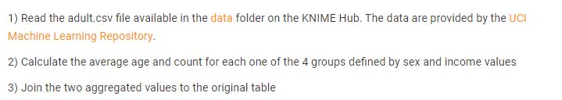

- Read the adult.csv file
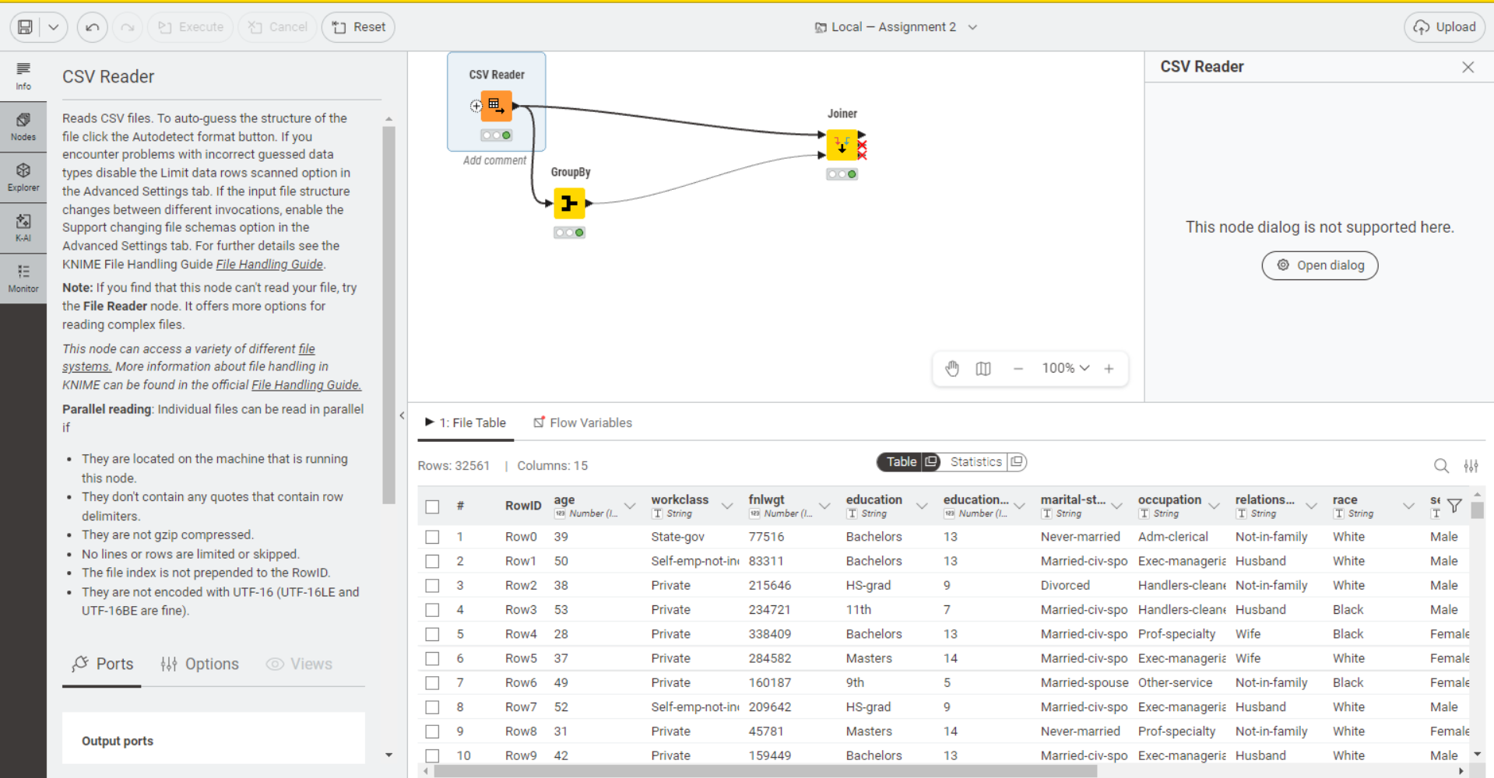

- Calculate the average age and count for each one of the 4 groups defined by sex and income values
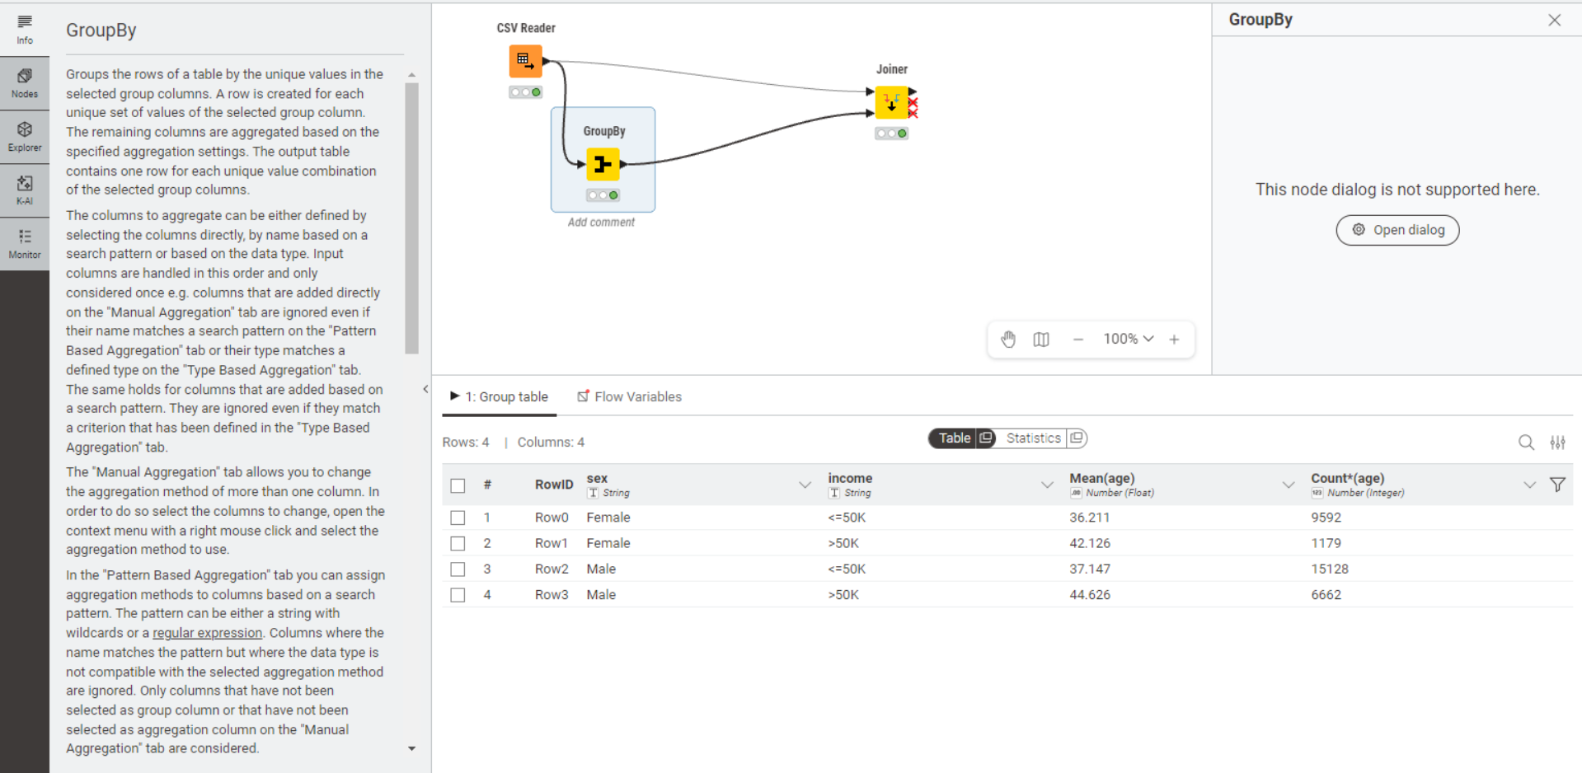

- Join the two aggregated values to the original value
